Part G – Effect of Signal Frequency

After using the simple predictor for the signal x₂[n] = 2 cos(0.6πn),
And also plotting the first signal’s error x[n] = 2 cos(0.05πn) + 0.5 cos(0.2πn).
We got those prediction error plots:
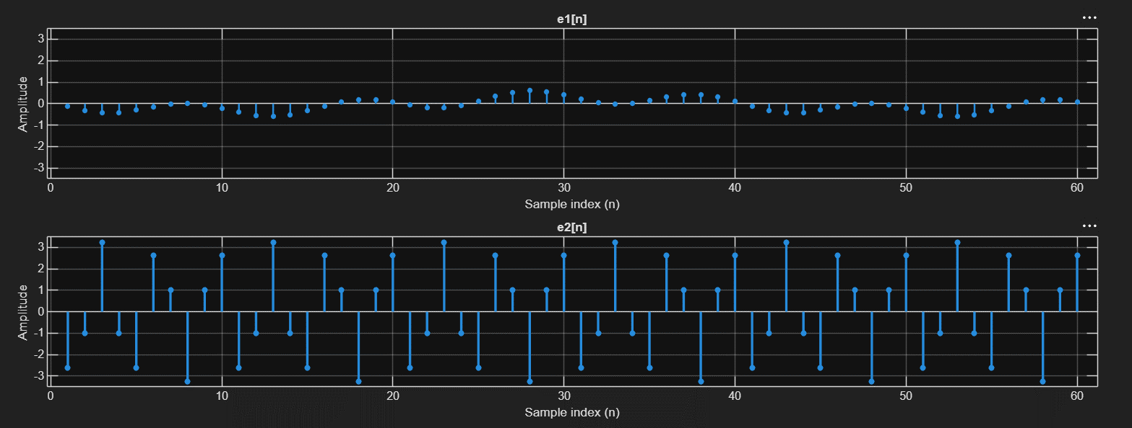

We should also compare the Prediction Gain:

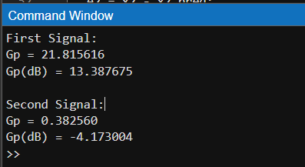

From the Gp alone, it is obvious that the first signal performs better for DPCM.

Questions:
- Which signal is easier to predict using the previous sample?
As we can see from the plots the first signal (with lower frequencies) is much easier to predict.
This is also confirmed by the prediction gain, which is positive for the first signal and negative for the second.

- Why?
Because it has low frequencies, causing strong correlation between adjacent samples, which makes the simple predictor that depends on previous samples (x̂[n] = x[n-1]) produce better results, making the difference between the sample and the prediction minimal, hence small prediction error.

- What does this demonstrate about the relationship between signal correlation and DPCM performance?
It demonstrates that DPCM performance depends heavily on the signals correlation. Strong correlation between samples, leads to smaller error, allowing DPCM to use less bits for quantization.
(The stronger the correlation, the better DPCM performs).

